Critical Incident Paper
The impact of climate change and the various policy proposals put forth to address it

Mariia Lukashenko
ECO 414-01: Intermediate Microeconomics
Dr. Baranes
October 8, 2025

Introduction
Climate change is not only an environmental and social challenge—it is also a profound economic problem, arising from market failures, externalities, and public goods dilemmas. Human activities, particularly the emission of greenhouse gases, impose significant negative externalities on society. These externalities—such as rising temperatures, extreme weather events, and damage to ecosystems—are costs not reflected in market transactions. By examining both the costs of inaction and the potential benefits of mitigation and adaptation, this critical incident emphasizes the need for well-designed policies to address one of the most urgent global challenges of our time.
Earth’s climate has undergone natural variations over centuries, but the rapid warming observed over the past century is unprecedented. Industrialization, beginning in the 18th century, marked the start of large-scale fossil fuel use, leading to the accumulation of carbon dioxide in the atmosphere. Since the middle of the 20th century, annual emissions of carbon dioxide from burning fossil fuels have increased every decade, from close to 11 billion tons of carbon dioxide per year in the 1960s to an estimated 37.4 billion tons in 2024 according to the Global Carbon Budget 2024 (See Figure 1). Based on the annual analysis from NOAA’s Global Monitoring Lab, global average atmospheric carbon dioxide was 422.8 parts per million in 2024, a new record high (See Figure 2) (Lindsey, 2025, a).
Glaciers are shrinking at an alarming rate, with the pace of loss in the World Glacier Monitoring Service reference network increasing from an average of 171 millimeters per year in the 1980s to nearly 889 millimeters per year in the 2010s (See Figure 3) (Lindsey, 2025, b). Global mean sea level has risen by roughly 8 to 9 inches since 1880, threatening coastal communities and ecosystems (See Figure 4) (Lindsey, 2023). Shifts in ecosystems have also become evident, with the United States experiencing an average of 70,000 recorded wildfires annually since 1983. Furthermore, extreme weather events are growing in frequency and severity; between 1980 and 2024, the United States alone experienced 403 confirmed climate and weather disasters, each causing losses exceeding one billion dollars (See Figure 5) (U.S. Environmental Protection Agency, 2025). These changes not only affect natural systems but also human societies, disrupting agriculture, labor productivity, infrastructure, and overall economic growth.
The scientific recognition of climate change dates back to the late 19th and early 20th centuries, when researchers first identified the greenhouse effect and the potential for carbon dioxide emissions to influence global temperatures. By the mid-20th century, empirical data began to confirm rising global temperatures and the link to human industrial activity (See Figure 1) (Lindsey, 2025, a)
The 1970s and 1980s marked a significant turning point in public awareness and policy development. Internationally, the 1992 United Nations Framework Convention on Climate Change (UNFCCC) represented a major milestone, establishing a platform for global cooperation on reducing emissions. This was followed by the Kyoto Protocol in 1997, which introduced binding targets for industrialized nations, and later the Paris Agreement in 2015, which emphasized nationally determined contributions and flexible, market-oriented approaches to reducing emissions. These developments reflect the increasing recognition of the economic, social, and ecological impacts of climate change. (Patt & Rajamani, 2022)

From a microeconomic perspective, climate change is a classic case of market failure, where market equilibrium for goods that generate emissions occurs at a quantity higher than socially optimal. The social cost curve lies above the private cost curve, representing the additional cost to society not considered by market participants. This creates allocative inefficiency, where too much of the harmful good is produced and consumed. (Varian & Melitz, p. 686)
Climate change also exemplifies the consequences of unregulated externalities. The atmosphere functions as a public good: it is non-excludable and non-rival, meaning that individuals and firms can emit greenhouse gases without directly bearing the costs, while the benefits of a stable climate are shared broadly. Between 2030 and 2050, climate change is expected to cause approximately 250 000 additional deaths per year, from malnutrition, malaria, diarrhoea and heat stress alone. The direct damage costs to health are estimated to be between USD 2-4 billion per year by 2030. This divergence between private and social costs leads to overproduction of pollution-intensive goods and underinvestment in cleaner alternatives. (World Health Organization, n.d.)
Tools like Pigouvian taxes, carbon taxes and cap-and-trade systems were designed to internalize these externalities, aligning private incentives with social welfare. Greenhouse-gas emissions, for instance, generate a classic negative externality: emitters enjoy the private benefits of energy and output while pushing non-marketed costs—heat waves, sea-level rise, crop losses, health damage—onto everyone else. Because no one naturally “owns” a stable climate, these costs are off the books, and the unregulated market produces too much of the bad. This dynamic leads to the “tragedy of the commons,” where collective overuse causes social harm. The atmosphere functions as a global commons, making it vulnerable to the tragedy of the commons.
A Pigouvian tax in this case charges those producers and consumers for the external costs their actions impose on society, effectively bridging the gap between private and social costs (See Figure 8). A carbon tax directly sets a price on carbon emissions, incentivizing firms and consumers to reduce emissions where it is most cost-effective. A cap-and-trade system, on the other hand, sets a limit on total emissions and allows firms to buy and sell emission permits, creating a market for pollution rights. All of those mechanisms aim to reduce emissions efficiently but differ in predictability and flexibility. Taxes provide price certainty, while cap-and-trade provides quantity certainty. (Varian & Melitz, p. 646)
Game theory is another great concept that can help us understand how countries and firms make choices that affect one another. It shows why cooperation in tackling global issues like climate change is so challenging—each player waits to see what the others will do, hoping to benefit without bearing all the costs. Yet, when nations act early with strong mitigation and adaptation strategies, the collective payoff is far greater, especially for regions most vulnerable to climate damage. By explaining how decisions in one country or firm affect others, game theory highlights the need for strong international cooperation and enforcement measures to overcome free-rider problems and achieve collective climate goals. (See Figure 7) (Varian & Melitz, p. 515)
Beyond pricing mechanisms, microeconomic theory also supports the use of subsidies to encourage investment in renewable energy and low-carbon technologies. Subsidies can shift the supply curve of clean technologies downward, reducing costs and accelerating adoption, complementing carbon pricing policies.

Critical Incident Overview
This critical incident emphasizes that climate change is not only an environmental challenge but also an economic one. Understanding the interplay of supply, demand, externalities, and policy tools allows economists and policymakers to design interventions that correct market failures, promote sustainable production, and guide behavior toward socially optimal outcomes. Climate change persists because emissions are underpriced, and cooperation is fragile. Negative externalities explain the over-emission; game theory explains the temptation to free ride. The solution is equally standard but must be executed with care: price the externality or cap it, let trading equalize marginal abatement costs, and reshape international incentives so cooperation is each country’s best response. Done together, these elements move the world from an inefficient equilibrium of chronic over-emission toward a self-enforcing, lower-cost path to durable decarbonization.
Learning Objectives
By the end of this critical incident, readers should be able to:
- Use supply and demand analysis to illustrate the social versus private costs of emissions, as well as Pigouvian taxes, cap-and-trade systems, and subsidies in internalizing externalities.
- Compare carbon taxes and cap-and-trade systems in terms of efficiency, predictability, and flexibility.
- Explain how game theory informs international negotiations and collective action in addressing climate change.

Questions (for the Critical Incident)
- Why is climate change considered a market failure, and how does this justify government intervention—especially through policies like carbon taxes or cap-and-trade systems?
- Why do the distributional effects of climate policy—specifically, who bears the costs and who gains the benefits—play such a powerful role in shaping political support or opposition?
- Why can renewable energy subsidies help—or sometimes interfere with—carbon pricing policies like taxes or cap-and-trade, and which approach is more effective for encouraging clean energy?

Answers (Define–Diagram–Discuss)

Question 1 –

Define:
- Market failure - a situation where free markets misallocate resources relative to social welfare; in the climate context this happens because private decisions ignore the social harms caused by greenhouse-gas emissions, so too much of the emissions is produced.
- Carbon tax – an application of a Pigouvian tax to greenhouse gases: it sets a price per ton of CO₂ giving continuous incentives to reduce emissions across the economy.
- Cap-and-trade – a quantity instrument where the regulator caps total emissions, issues or auctions tradable allowances up to that cap, and lets firms trade so the market discovers the allowance price that equalizes marginal abatement costs.

Discuss:

Climate change represents one of the most significant and persistent market failures in modern economics. At its core, this failure arises because the costs of emitting carbon dioxide (CO₂) and other greenhouse gases are not reflected in market prices. These unpriced external damages distort resource allocation, leading to excessive emissions and inefficient outcomes.

In a well-functioning market, the marginal social cost (MSC) of producing an extra unit of output would equal the marginal benefit (MB) derived from that output. For CO₂ emissions, the efficient allocation requires that the MSC of emitting one more ton equals the marginal benefit from the energy services it provides. However, without regulation, emitters only face their marginal private cost (MPC)—the direct cost of production—while ignoring the marginal damage (MD) their pollution causes to society. This creates a wedge between social and private costs:

$$MSC(q)=MPC(q)+MD(q)$$

As a result, the competitive equilibrium condition MB ($q_{LF}$) = MPC( $q_{LF}$) leads to a higher emission level $q_{LF}$ than is socially optimal. The efficient outcome occurs where MB (q*) = MSC(q*). A Pigouvian carbon tax provides an effective solution. By imposing a tax equal to the marginal external damage at the efficient quantity t* = MD(q*) the government ensures that emitters internalize the true social cost of their emissions. Firms then face the full cost of their actions: their private cost plus the tax. They will choose to reduce emissions whenever their marginal abatement cost (MAC) is less than the tax, thereby aligning private incentives with social welfare. In equilibrium, the market condition becomes MB (q) = MPC (q) + t*, which reproduces the efficient outcome MB (q*) = MSC(q*).

The marginal benefit curve (MB) intersects the marginal private cost curve (MPC) at the laissez-faire level $q_{LF}$, showing overproduction of emission-intensive output. The marginal social cost curve (MSC), which includes external damages, lies above MPC. The efficient point q* occurs where MB equals MSC. The vertical distance between the two cost curves at q* shows the optimal Pigouvian tax t* = MD(q*). This tax raises the effective price of carbon intensive goods, curbing consumption and emissions to efficient levels. Pricing the externality aligns private incentives with social welfare, curbs over-emission, and does so at least cost by letting heterogeneous emitters choose their cheapest abatement options. Cap-and-trade implements the same idea by fixing quantity and letting the permit price play the role of t. A carbon tax implements t* directly; a cap-and-trade program chooses an emissions cap so that the equilibrium permits price equals the shadow value of the constraint.

Diagram:

Question 2 –

Define:
- Distributional effects. How the costs and benefits of a policy are spread across people, firms, regions, and income groups; these patterns determine who feels hurt or helped and therefore strongly influence political support or opposition.
- Climate club. A coalition of countries that jointly commit to stronger climate action and provide exclusive benefits (e.g., preferential trade, finance, technology access, or lower tariffs) to members; the club uses club goods and incentives to make participation attractive and reduce free-riding, aiming to raise ambition above the non-cooperative baseline.

Discuss:

In international mitigation, the strategic baseline is a prisoner’s dilemma: each country prefers to free-ride on others’ cuts, so the Nash equilibrium is mutual under-mitigation even though coordinated action would make all better off. “Climate clubs” try to change those payoffs—club benefits for cooperators and credible penalties for defectors—so that joining is better than free-riding.

Within countries, the same logic appears at a smaller scale. Firms and households face different abatement costs and receive different slices of climate benefits (health, avoided damages, green rents). When policy equalizes marginal abatement costs across sources, total costs are minimized; when it does not, some groups overpay and mobilize opposition. Distribution, not just efficiency, thus shapes the coalitions for or against any given design.

International cooperation is a great example of prisoner’s dilemma: each country has a short-run incentive to free-ride, so the default outcome is under-mitigation. Climate clubs flip that calculus by adding benefits for members and penalties for outsiders (market access vs. border adjustments). With credible monitoring and timely enforcement, joining beats defecting; without credibility, the game slips back to free-riding. At the micro level, hit a given target at least cost by equalizing marginal abatement costs. In the NOx example with two firms sharing a total cap X, the efficient condition is $c_{1}^{'}\left(x_{1}\right)$ = $c_{2}^{'}(x_{2})$. Carbon pricing or tradable permits let low-cost sources over-comply and sell, high-cost sources buy instead of making very expensive cuts-lowering costs and creating visible winners who defend the policy.

Diagram:

Without transfers, at least one group loses and prefers Oppose. With revenue recycling and side-payments, pivotal groups move to nonnegative payoffs, expanding the Support–Support basin.

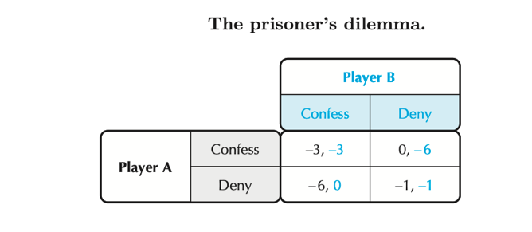

Question 3 –

Define:
- Carbon tax – an application of a Pigouvian tax to greenhouse gases: it sets a price per ton of CO₂ giving continuous incentives to reduce emissions across the economy.
- Cap-and-trade – a quantity instrument where the regulator caps total emissions, issues or auctions tradable allowances up to that cap, and lets firms trade so the market discovers the allowance price that equalizes marginal abatement costs.
- Marginal Abatement Cost (MAC). The additional cost of reducing one more unit of emissions; efficiency requires MACs be equalized across firms so abatement occurs where it’s cheapest.

Discuss:
One important part in understanding this problem is the fact that there is a missing market—the market for the pollutant. The externality problem arises because the polluter faces a zero price for an output good that it produces, even though people would be willing to pay money to have that output level reduced. From a social point of view, the output of pollution should have a negative price. We could imagine a world where the fishery had the right to clean water but could sell the right to allow pollution. Let q be the price per unit of pollution, and let x be the amount of pollution that the steel mill produces. Then the steel mill’s profit-maximization problem is
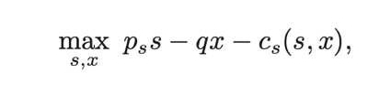
Internalizing the climate externality requires putting a price on emissions or directly limiting their quantity.

A Pigouvian side of the problem: pollution is unpriced, so firms ignore the harm. Carbon pricing fixes this either by a tax (put a price per ton) or cap-and-trade (fix quantity; trading finds the price). In cap-and-trade, firms trade until marginal abatement costs (MACs) equalize, so the allowance price = common MAC at the target. Renewable subsidies work from the other side: they lower clean-tech costs, pushing the MAC curve down over time. The main idea is that pricing gives the signal, while subsidies make the response cheaper and faster.

Subsidies help because markets under-invest in innovation and adoption; buying down risk and cost speeds learning and grid build-out, so less carbon price is needed for a given cut. Under a carbon tax, cheaper abatement means extra emissions cuts at the same tax. But under a fixed cap, extra renewables mostly lower the allowance price without changing total emissions—the “waterbed” effect—unless the program has a price floor/reserve or the cap tightens.

So, which is more effective for clean energy? For least-cost economy-wide cuts, a predictable carbon price is the backbone. For rapid clean build-out when prices are too low or politically constrained, targeted subsidies can deliver faster deployment and learning. Best practice: run both - keep a strong price (tax or cap with floor/ceiling and auctioning) and use focused subsidies for R&D, early deployment, grids, and storage—then tighten the cap or raise the tax path so cheaper abatement yields more abatement, not just cheaper permits.

Diagram:
Epilogue
The aftermath and impact of the climate crisis are now unmistakably evident across environmental, social, and economic dimensions. Decades of unpriced emissions have led to a measurable transformation of the planet. The “incident” of prolonged inaction has triggered a global response: nations have adopted carbon pricing, renewable subsidies, and international agreements to correct the market failure and mitigate further damage. Policies like the EU Emissions Trading System and the Paris Agreement’s climate clubs demonstrate how coordinated action can internalize externalities and shift incentives toward sustainability. The experience has also underscored a crucial lesson: the costs of inaction vastly exceed the costs of mitigation, making climate policy not only an environmental necessity but an economic imperative for long-term global stability.

Sources -
- Varian, H. R., & Melitz, M. J. (2023). Intermediate microeconomics: A modern approach (11th ed.). W. W. Norton & Company.
- Alcamo, J. (1996). Integrated modeling of global climate change: Uncertainty and indicators. International Institute for Applied Systems Analysis (IIASA). https://pure.iiasa.ac.at/id/eprint/5025/1/CP-96-001.pdf

- International Monetary Fund. (2019, December). Finance & Development: Climate change and the economics of the future. https://www.imf.org/external/pubs/ft/fandd/2019/12/pdf/fd1219.pdf

- Organisation for Economic Co-operation and Development (OECD). (2015). The economic consequences of climate change. OECD Publishing. https://www.oecd.org/content/dam/oecd/en/publications/reports/2015/11/the-economic-consequences-of-climate-change_g1g558e1/9789264235410-en.pdf

- Batini, N., & Pfeiffer, P. (2021). Climate change and monetary policy in the euro area (ECB Occasional Paper Series No. 243). European Central Bank. https://www.ecb.europa.eu/pub/pdf/scpops/ecb.op243~2ce3c7c4e1.en.pdf

- Nordhaus, W. D. (2002). Modeling induced innovation in climate-change policy. The American Economic Review, 92(1), 345–349. https://pubs.aeaweb.org/doi/pdfplus/10.1257/0895330027283

- Congressional Research Service. (2019). Climate change risk disclosure under the securities laws (IF11156). https://www.congress.gov/crs-product/IF11156

- United Nations Environment Programme Finance Initiative (UNEP FI). (2022). Economic impacts of climate change. https://www.unepfi.org/wordpress/wp-content/uploads/2022/05/Economic-Impacts-of-Climate-Change.pdf

- Hewitt, J. (2021, June 23). Climate change: What are the economic impacts and potential solutions? Economics Observatory. https://www.economicsobservatory.com/climate-change-what-are-the-economic-impacts-and-potential-solutions

- Varian, H. R., & Melitz, M. J. (2020). Intermediate microeconomics: A modern approach (10th ed.). W. W. Norton & Company.

- National Aeronautics and Space Administration (NASA). (n.d.). The effects of climate change. https://science.nasa.gov/climate-change/effects

- National Oceanic and Atmospheric Administration (NOAA). (May 21, 2025). Rebecca Lindsey, a. Climate change: Atmospheric carbon dioxide. https://www.climate.gov/news-features/understanding-climate/climate-change-atmospheric-carbon-dioxide

- National Oceanic and Atmospheric Administration (NOAA). (May 9, 2025). Rebecca Lindsey, b. Climate change: Mountain glaciers. https://www.climate.gov/news-features/understanding-climate/climate-change-mountain-glaciers

- National Oceanic and Atmospheric Administration (NOAA). (August 22, 2023). Climate change: Global sea level. https://www.climate.gov/news-features/understanding-climate/climate-change-global-sea-level

- United States Environmental Protection Agency (EPA). (2023). Climate change indicators: Ecosystems. https://www.epa.gov/climate-indicators/ecosystems

- National Centers for Environmental Information (NCEI). (2024). U.S. billion-dollar weather and climate disasters: State summary. https://www.ncei.noaa.gov/access/billions/state-summary/US

- Intergovernmental Panel on Climate Change (IPCC). Patt & Rajamani. (2022). Mitigation of climate change: Chapter 14 – International cooperation. In AR6 Working Group III contribution to the Sixth Assessment Report. https://www.ipcc.ch/report/ar6/wg3/chapter/chapter-14/

- World Health Organization (WHO). (n.d.). Public health and environment data. https://www.who.int/data/gho/data/themes/public-health-and-environment

Figure 1 –
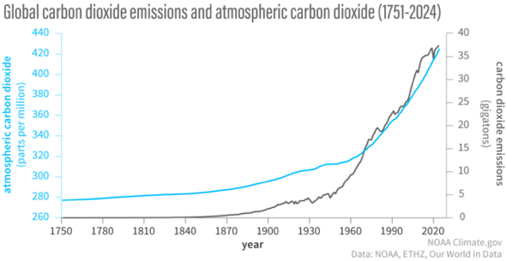
Figure 2 -
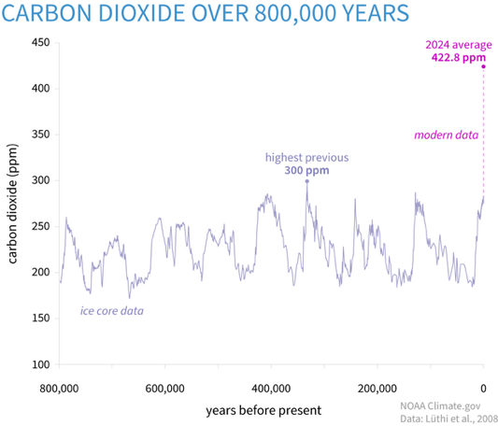
Figure 3 -
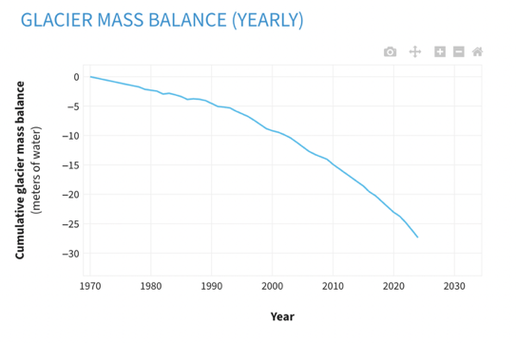
Figure 4 –
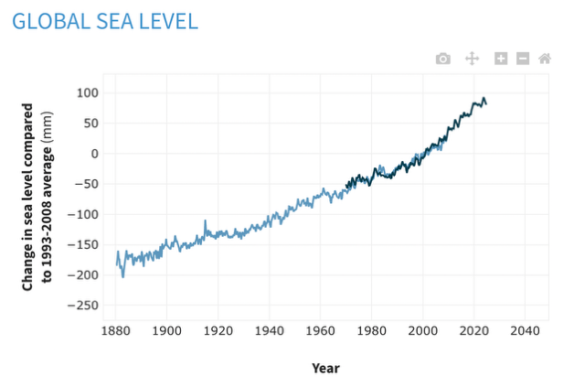

Figure 5 –
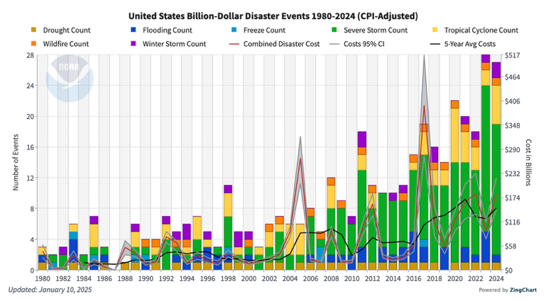
Figure 6 –
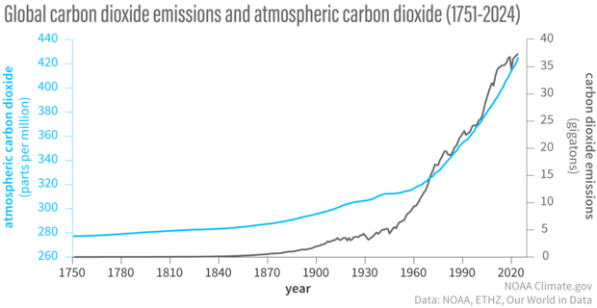
Figure 7 –
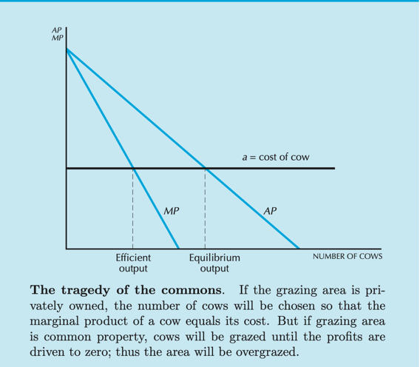

Figure 8 –
